“Unless they are furnished with an adequate blood supply and a means of disposing of their waste products by a mechanism other than diffusion, solid tumours cannot grow beyond a few millimetres in diameter”

Tumor can’t grow without excess nutrients

“The progress and development of a solid tumour from a small dormant mass of cells, a few millimetres in diameter, into an invading metastatic cancerous growth, depends upon its ability to induce endothelial cells of neighbouring capillaries in the surrounding tissue to sprout towards and eventually penetrate the tumour, thus providing it with an adequate blood supply and microcirculation”

Tumor needs to draw in blood vessels to get nutrients pumped into it

“It is now a well established fact that, in order to initiate and make the transition from the avascular phase to the vascular phase, solid tumours secrete a diffusable chemical compound known as tumour angiogenesis factor (TAF) into the surrounding host tissue and extracellular matrix (ECM).”

Tumor secretes TAF to draw blood vessels to it

“New features that are included in the model are the consideration of **finite boundaries** and a **critical distance** between the turnour/ tumour implant and the neighbouring capillary vessels (e.g. in the limbus), **a natural decay term for the TAF** and a **sink term for TAF**, modelling the action of proliferating endothelial cells. “

“However, once the capillary sprouts have formed, it is only cells at the tips of the sprouts that are actively migrating and reproducing. Ausprunk & Folkman hypothesized that the reason for this restricted proliferation was that these cells or vessels at the sprout tip were acting as sinks for the TAF.”

Sink terms get brought up repeatedly…

“Thus, we hope that this paper in some sense provides a link between two previous models dealing with tumour angiogenesis and neovascularization: those of Balding & McElwain (1985) and Chaplain & Sleeman (1990). **In the former the modelling of the formation and growth of the capillaries was undertaken based on the fungal growth model of Edelstein** (1982), **while in the latter attention was focused primarily on the production of TAF within the tumour prior to its secretion into the host tissue**.”

“Once a steady state has been reached, two possibilities arise. **The first is that the distance between the tumour and the neighbouring vessels is below the critical threshold distance (Gimbrone et al. 1974), and so the endothelial cells cannot react to the angiogenic stimulus, and thus no cell migration and sprouting takes place**. The second possibility, and the one which we shall concentrate upon, is that the tumour is within the critical distance and hence capillary growth can take place. This constitutes the second phase of the model”

Regarding bold: do they mean *above* the distance as in too far away or to cells that are too close not react?

Initially, cell proliferation is seen only in the area of the parent vessel at the base of the outgrowing capillaries (cf. Paweletz & Knierim, ***1990).*** However, once the capillary sprouts have formed, it is only cells at the tips of the sprouts that are actively migrating and reproducing. Ausprunk & Folkman hypothesized that the reason for this ***restricted proliferation*** was that these cells or vessels at the sprout tip were ***acting as sinks*** for the TAF.

*TAF doesn’t move blood vessels, it causes them to for sprouts, which grow in the direction of the TAF, causing them to expand closed to the Tumor*

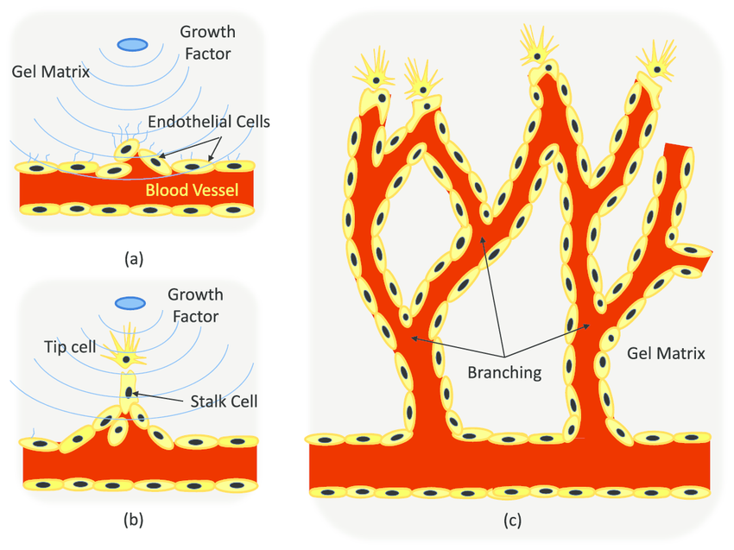[source](https://www.researchgate.net/figure/Angiogenic-sprouting-process-a-ECs-residing-in-a-blood-vessel-sprout-out-in-response_fig1_220121784)

By following the movement of the boundary of the TAF as it recedes, we also have a way of ***(indirectly)*** tracking the movement of the capillary tips as they make their way across the extracellular matrix moving up the ***TAF*** concentration gradient towards the source of the angiogenic stimulus, the solid tumor itself.

*As stated previously, we can track the movement of the sprouting vessels buy following the concentration gradient to its most potent area — the tumor itself.*

The TAF is assumed to diffuse with rate constant *D* and to be absorbed by the surrounding host tissue at a rate *g(c)*. (Note from a later page…) we shall concentrate on the simple choice g(c) = **m,** where m is a constant (cf. Galib ***et*** al., 1981) since it captures the right qualitative features.

*So we can assume a diffusion rate of D and an absorption rate of m.*

Also, whenever the tumor extracts are removed (cf. Gimbrone ***et al.,*** 1974), the capillary sprouts are seen to regress. In modeling the regression of the tips, Balding & McElwain (1985) assumed that the T A F concentration level had decayed to zero. Thus, in this first phase of the model, a decay or sink term is included in a diffusion equation for the TAF concentration.

*Removal of a TAF supply causes the vessels sprouted to retreat back to their root.*